Learning Journal Unit 6

Godfrey Ouma
University of the People
MATH 1211: Calculus
Rakesh Das
December 28, 2023

Learning Journal Unit 6
Question 1:
For any problem that you couldn’t solve at first, suggest a strategy you might try to tackle the problem and show what happened as a result.
The problem I initially struggled with was "Setting up Related-Rates Problems." To tackle this problem, Herman and Strang (2020) proposed a strategy that I attempted, resulting in valuable insights. The strategy involved a series of steps:
- Assign symbols to all involved variables and, if applicable, create a corresponding diagram.
- Express the given information and the rate to be determined in terms of the identified variables.
- Establish an equation interrelating the variables outlined in step 1.
- Employ the chain rule to differentiate both sides of the equation from step 3 concerning the independent variable. This derivative equation establishes a connection between the derivatives.
- Substitute the known values into the equation derived in step 4 and solve for the unknown rate of change.
- However, challenges surfaced due to premature substitution of known values. Substituting a changing quantity's value into an equation before differentiating both sides of the equation causes that quantity to behave as a constant. Consequently, its derivative does not appear in the new equation obtained in step 4, hindering the solution process.

Question 2:
- Describe any strategic gaps you were unable to bridge
The strategic gap I encountered involved the utilization of concavity and inflection points to elucidate how the second derivative's sign influences a function's graph shape.
- List three helpful insights that may help another person trying to tackle the problem
- Second Derivative and Concavity: To comprehend a function's concavity, evaluate its second derivative, f ′′(x). This derivative reveals the concavity's nature at different points along the function's curve.
- Change in Concavity: Remember, a function's concavity can change, but this alteration occurs solely at a point x if f ′′(x)=0 or f ′′(x) is undefined. These points signify potential shifts in concavity.
- Identifying Intervals and Inflection Points: Pinpoint values of x where f ′′(x)=0 or f ′′ (x) is undefined to determine intervals of concave up or down. Afterward, divide the function's domain into smaller segments and assess the sign of (x) within each. When the sign of (x) changes at a particular x, it indicates a shift in concavity. However, note that even if (x)=0 or (x) is undefined at a point x, the function's concavity might remain unchanged unless the function is continuous at that point. Finally, if a function changes concavity at a point a while remaining continuous, the point [a, f(a)] is recognized as an inflection point for f(x) (Herman & Strang, 2020).
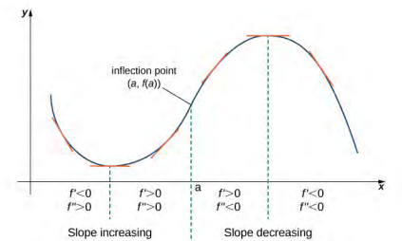
Since f ″(x) > 0 for x < a, the function f is concave up over the interval (−∞, a). Since f ″(x) < 0 for x > a, the function f is concave down over the interval (a, ∞). The point [a, f(a)] is an inflection point of f(x).

Reference
Herman, E. & Strang, G. (2020). Calculus volume 1. OpenStacks. Rice University.

